Gibbs - Reflective Cycle model (1988)
The Gibbs' reflective cycle, inspired partly by Kolb's learning cycle, enables us to focus especially on our own and others' feelings, views and perceptions. In common terms people call this "Standing/walking in someone else's shoes". This relates strongly to ideas about empathy.
The process is essentially a cycle or loop, containing the following elements:
- Description - What happened?
- Feelings - What were you thinking and feeling?
- Evaluation - What was good and bad about the experience?
- Analysis - What sense can you make of the situation?
- Conclusion - What else could you have done?
- Action Plan - If it arose again what would you do? (back to 1 Description)
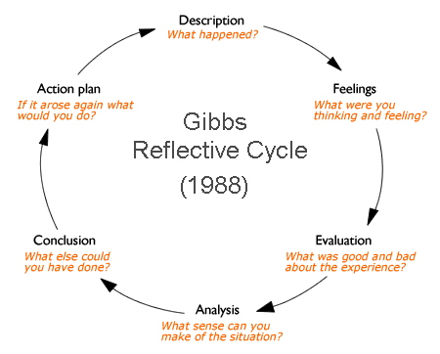
(Diagram: Gibbs G [1988] Learning by Doing: A guide to teaching and learning methods. Further Education Unit. Oxford Polytechnic: Oxford. [Brookes.ac.uk])
Having empathy can help us to see beyond our own actions, feelings and motivations to imagine how another person might be feeling; what their different views and opinions might be; and how these factors can influence the situation.
It is usually easier (and therefore a natural tendency) to blame others for problems, than to consider our own responsibilities in a particular situation.
Also, we can only change what is in our control to change.
The Gibbs model encourages the use of critical reflection, and especially offers a good starting point for people first using Reflective Practice, in converting new learning and knowledge into action and change.
The process requires that we look beneath the surface of events and experiences, to achieve deeper levels of reflection and learning.

